|  |  |
| --- | --- |
| **Ex. No. 6** | **J*A*VASCRIPT - TIMER FUNCTIONS AND OBJECTS** |
| **Date of Exercise** | 29/08/2022 |
| **Web Host Link** |  |
| **You-Tube Link** | https://drive.google.com/file/d/10OZSP3QfLE-h2MzP_x6AdzsbFfm1eKnG/view?usp=share_link |

**Aim:**

**To create web pages using va**rious timer functions, events and objects **in JavaScript**.

**Description:**

Timing Events The window object allows execution of code at specified time intervals. These time intervals are called timing events. The three key methods to use with JavaScript are:

**setTimeout(*function, milliseconds)***

Executes a function, after waiting a specified number of milliseconds.

Ex: window.setTimeout*(function, millisecond*s);

**setInterval(*function, milliseconds*)**

Same as setTimeout(), but repeats the execution of the function continuously.

Ex: window.setInterval*(function, millisecond*s);

The **clearInterval()** method stops the executions of the function specified in the

setInterval() method.

EX:window.clearInterval*(timerVariable)*

**Date Object**: Date Object gives various methods to multiple ways to access date, month, year details.

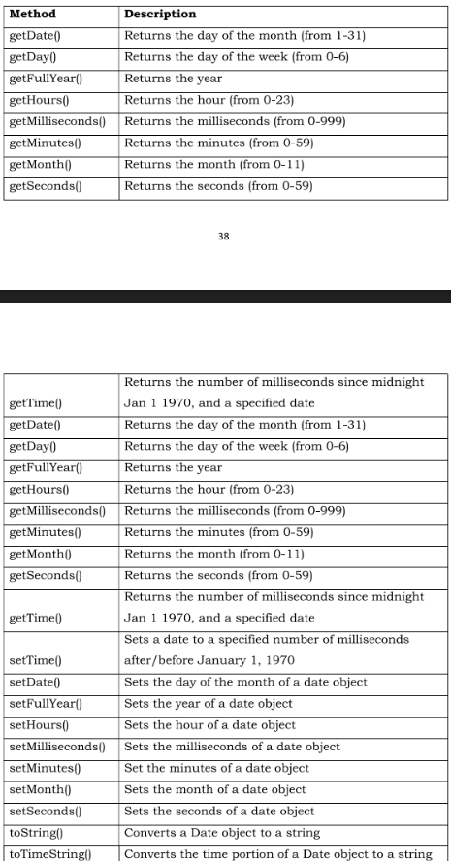



**QUESTIONS:**

1. **Write JavaScript code to display digital clock.**
2. **Write JavaScript code to change background colour for every 30 seconds.**
3. **Create event handlers that will increase the font size when a mouse moves over a paragraph and decrease the size when the mouse moves off the paragraph.**
4. **Write JavaScript code to move absolutely-positioned car image when a user clicks the move button and stop the car image when a user clicks the stop button on the following webpage.**
5. **Create an array of objects, where each object describes about a student and his/her properties for the name (a string), regno (a string) and year of birth (a number). Iterate through the array of students and display it on the web page. For each student, print the student name and register no like so: "John's Register Number is UR13CS129". Now use an if*/*else statement to categorize the students they have date of birth before 2000 and after 2000.**

**Program:**

**HTML CODE:**

<!DOCTYPE HTML>

<HTML>

    <head>

        <style>

            body {

  font-family: system-ui;

  color: black;

  text-align: center;

  font-size: 20px;

}

</style>

<head>

    <body>

            <h1 class="text-center p-5 text-warning">JAVASCRIPT - TIMER FUNCTIONS AND OBJECTS</h1>

<hr>

<h5 class="text-center text-white bg mt-5">1. Digital Clock</h5>

<div id = "clock" onload="currentTime()"></div><br>

<hr>

<h5 class="text-center text-white bg mt-5">2. Background Color Change</h5>

<div id="background">&nbsp</div>

<hr>

<h5 class="text-center text-white bg mt-5">3. Change font size!</h5>

<p id="paral" onmouseover="incSize()" onmouseout="decSize()"> move cursor over me to zoom in... </p>

<hr class="border border-warning border-2 opacity-50">

<section id="Q4">  <!--height="120" width="340"-->

    <h5 class="text-center text-white bg mt-5">4. Moving Car</h5>

    <div class="container-fluid mt-5">

        <img id="car" class="m-4" src="https://www.hyundai.com/content/dam/hyundai/au/en/models/side-profiles/2022-side-profiles/Hyundai_i30-SEDAN-Nline_Fiery-Red_Side-Profile_640x331.png" height="60" width="170" alt="car-img" style="position: relative; left: 0px">

        <div class="text-left ">

            <button class="btn btn-outline-success m-3" onclick="q4Start()">Start</button>

            <button class="btn btn-outline-danger m-3" onclick="q4Stop()">Stop</button>

        </div>

    </div>

    <h5 id="convertedValue" class="text-left text-warning mb-5"></h5>

    <hr class="border border-warning border-2 opacity-50">

</section>

<section id="Q5">

    <h3 class="text-center text-white bg mt-5">5. Array of Objects</h3>

    <div class="container col-sm-12 mt-5">

        <div class="text-center">

            <button class="btn btn-outline-warning mb-5" onclick="q5()">Print Student Details</button>

        </div>

        <div class="row" font-size="16px;">

            <div class="col-sm-6 text-center font-size=16px;">

                <h5 id="bfr" class="text-warning"></h5>

                <p id="before" class="text-warning"></p>

            </div>

            <div class="col-sm-6 text-center font-size=16px;">

                <h5 id="aft" class="text-warning"></h5>

                <p id="after" class="text-warning"></p>

            </div>

        </div>

    </div>

    <h5 id="details" class="text-center text-warning font-size=16px;"></h5>

    <hr class="border border-warning border-2 opacity-50">

</section>

<div class="p-5 text-center">

    <p class="text-warning">© Sumeet Kumar Gamango</p>

</div>

<script src="ex6.js"></script>

</body>

</html>

**JS CODE:**

function currentTime() {

    let date = new Date();

    let hh = date.getHours();

    let mm = date.getMinutes();

    let ss = date.getSeconds();

    let session = "AM";

    if(hh === 0){

        hh = 12;

    }

    if(hh > 12){

        hh = hh - 12;

        session = "PM";

     }

     hh = (hh < 10) ? "0" + hh : hh;

     mm = (mm < 10) ? "0" + mm : mm;

     ss = (ss < 10) ? "0" + ss : ss;

     let time = hh + ":" + mm + ":" + ss + " " + session;

    document.getElementById("clock").innerText = time;

    let t = setTimeout(function(){ currentTime() }, 1000);

  }

  currentTime();

  var i = 0;

function change() {

  var doc = document.getElementById("background");

  var color = ["black", "blue", "brown", "green","red","orange","pink"];

  doc.style.backgroundColor = color[i];

  i = (i + 1) % color.length;

}

setInterval(change, 2000);

function incSize(){

  document.getElementById("paral").style="font-size:28px";}

function decSize(){

  document.getElementById("paral").style = "font-size:10px";

}

function q4Start(){

  car=document.getElementById("car");

  interval=setInterval(q4CarMove,20);

}

function q4Stop(){

  clearInterval(interval);

}

function q4CarMove(){

  car.style.left=parseInt(car.style.left)+2+"px";

  if(parseInt(car.style.left)>parseInt(screen.width)){

      car.style.left="0px";

  }

}

function q5(){

  document.getElementById("bfr").innerHTML="Before 2000";

  document.getElementById("aft").innerHTML="After 2000";

  let student=[{Name:"Sumeet Kumar Gamango",RegNo:"URK20CS2087",DOB:"09/JUN/2002"},

               {Name:"Rahul Kumar",RegNo:"URK20AI1098",DOB:"03/JUL/2001"},

               {Name:"Aaron Lakra",RegNo:"URK20AI1072",DOB:"04/NOV/1999"},

               {Name:"Anmol Ephraim",RegNo:"URK20CS2082",DOB:"23/SEP/1998"},

               {Name:"Mansib Sahoo",RegNo:"URK20CS3010",DOB:"20/AUG/2001"}

              ]

  for(let i=0;i<student.length;i++){

      if(parseInt(student[i].DOB.split("/")[2])<2000){

          document.getElementById("before").innerHTML+=student[i].Name+"\'s "+"Register Number is "+student[i].RegNo+" and the DOB is "+student[i].DOB+"<br><br>";

      }

      else

      document.getElementById("after").innerHTML+=student[i].Name+"\'s "+"Register Number is "+student[i].RegNo+" and the DOB is "+student[i].DOB+"<br><br>";

  }

}

**Output:**

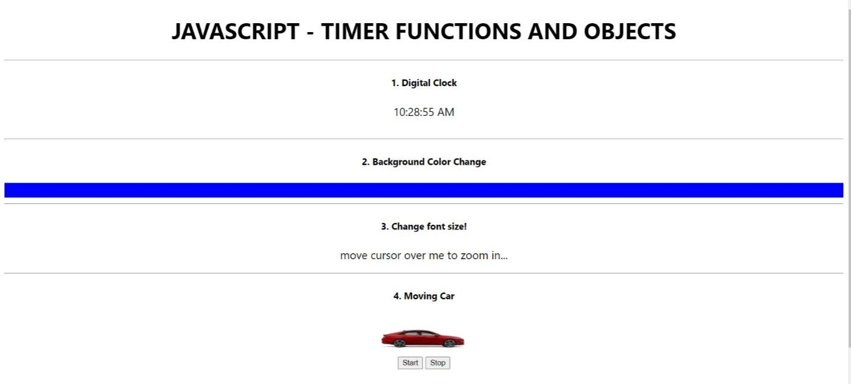

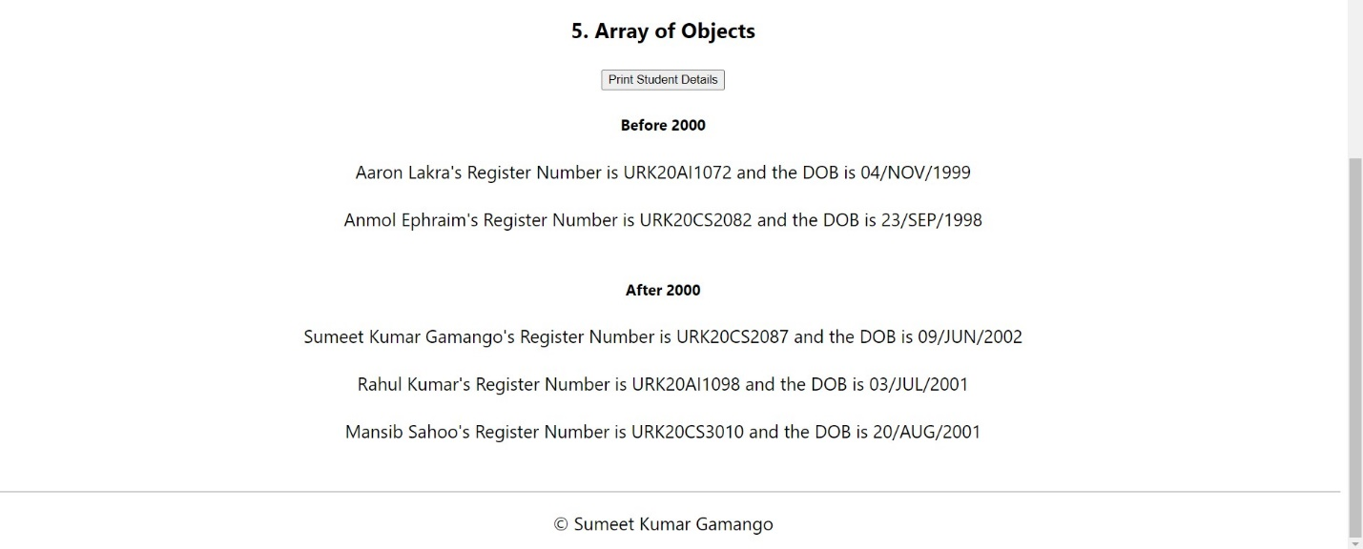

**Result:**

A website with all the solution for the given questions was created and the intended results were obtained successfully.